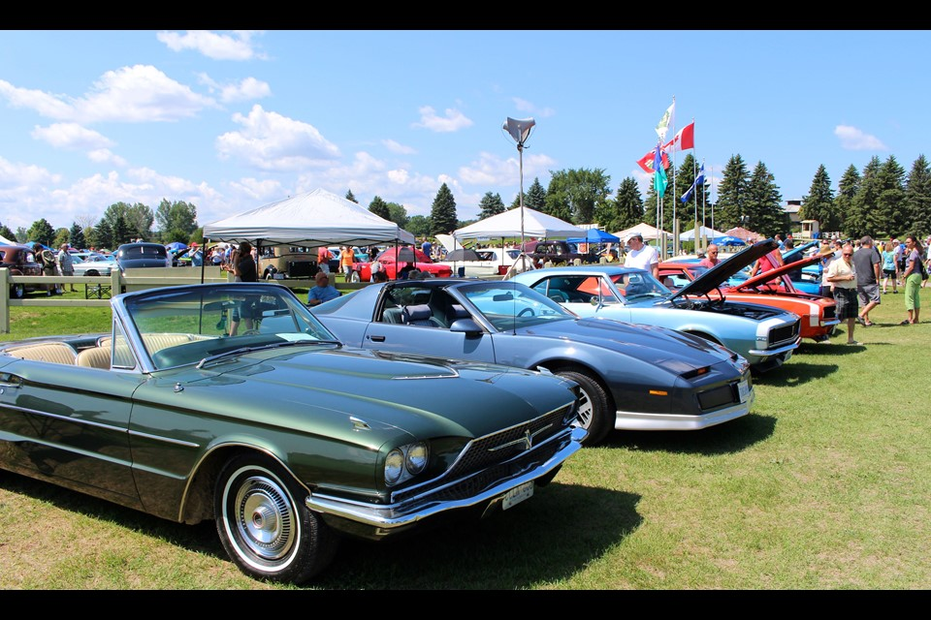
SATURDAY JUNE 13th, 2026
10 AM - 2 PM
13752 HWY 4 Wentworth, NS
Canteen available all day!!!
ENTRANCE FEE BY DONATION FOR CARS
Show & Shine on the ball field 10 AM until 2 PM
ADMISSION $2.00 UNDER 12 FREE
For additional info contact: Sandra: (902) 899-8583
Email: sandra.mayne@ns.sympatico.ca

